**Assembling the Linear Motor**

The Make to Learn Linear Motor (Figure 1) consists of a cylindrical magnet inside a tube. An external magnetic force can move the magnet inside the tube back and forth. End posts on either side of the tube prevent the magnet from falling out of the tube.

*Figure 1. Enclosure for Linear Motor*

A metal rod with protective caps on the ends is placed on either side of the magnet. The assembly consisting of the magnet and the two metal rods is known as the armature of the motor.

*Figure 2. Exploded View of the Armature*

Segments of ferrous rod (one-tenth inch in diameter) were used to construct the armature. Because the metal in the rod contains iron, the force of the magnet causes the rod to adhere to it. A protective cap is placed on each end of the metal rod.

The assembly that encloses the armature consists of a tube with two support extensions on each end that support the magnet as it moves into and out of the tube.

*Figure 3. Exploded View of Armature Enclosure Assembly*

The armature and armature enclosure can be attached to a 3D-printed mount that allows the motor to be placed in different orientations. One of the solenoid supports is replaced with a matching support that can be screwed onto the mount. The base of the mount is secured by a small weight.

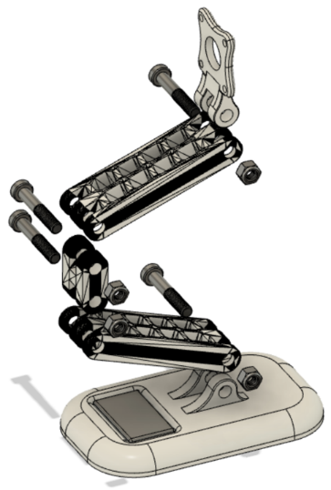

*Figure 10. Exploded View of the Linear Motor Platform*

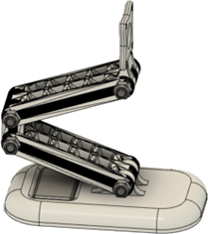

*Figure 11. Linear Motor Mounted to the Motor Platform*

An animated video illustrates the order of assembly:

[Assembling a Linear Motor](https://youtu.be/fgp2LUQHI5w)

The assembly steps are described below. When assembled, the combined length of the armature components should be slightly less than the distance between two end posts. This ensures room for the armature to move back and forth during operation of the motor.

1. *Assemble the Armature*
   1. Place protective caps on the ends of each ferrous rod.
   2. Place each segment on each end of the magnet.
2. *Assemble the Solenoid Enclosure*
   1. Screw together the enclosure to secure the solenoid supports and end caps.
3. *Assemble the Motor Platform*
   1. Replace one of the solenoid supports with the platform mount.
   2. Screw each part of the platform together.
   3. Add a small weight onto the platform to stabilize it.